- Write a bash script to print the reverse of a given number.

Code:

#!/bin/bash
read -p "Enter a number: " num
temp=$num
reverse=0
while [ $num -gt 0 ]; do
remainder=$((num % 10))
reverse=$((reverse * 10 + remainder))
num=$((num / 10))
done
echo "Reverse of $temp is $reverse"

Output:

- Write a bash script to add 2 float numbers.

Code:
#!/bin/bash
echo "Enter the two float numbers to be added:"
read num1
read num2
sum=$(echo "$num1 + $num2" | bc)
echo "The sum is: $sum"

Output:
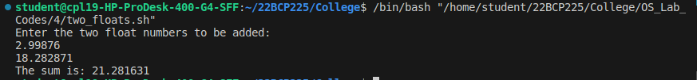

- Write a bash script for a menu driven calculator for + -* /

Code:
#!/bin/bash
echo "Menu-driven Calculator"
echo "1. Addition"
echo "2. Subtraction"
echo "3. Multiplication"
echo "4. Division"
echo -n "Enter your choice: "
read choice
echo -n "Enter the first number: "
read num1
echo -n "Enter the second number: "
read num2
case $choice in
1) result=$(echo "$num1 + $num2" | bc) ;;
2) result=$(echo "$num1 - $num2" | bc) ;;
3) result=$(echo "$num1 * $num2" | bc) ;;
4) result=$(echo "scale=2; $num1 / $num2" | bc) ;;
*) echo "Invalid choice" ;;
esac
echo "Result: $result"

Output:
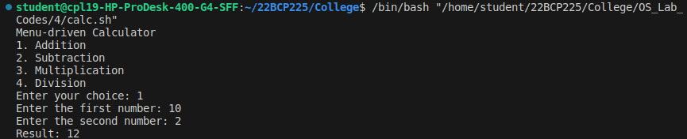
- Write a bash script to add the digits of a number.

Code:
#!/bin/bash
echo "Enter a number: "
read num
sum=0
while [ $num -gt 0 ]; do
digit=$((num % 10))
sum=$((sum + digit))
num=$((num / 10))
done
echo "Sum of the digits: $sum"

Output:
- Write a bash script to print the factorial of a number.

Code:
#!/bin/bash
echo "Enter a number: "
read num
fact=1
for ((i = 2; i <= num; i++)); do
fact=$((fact * i))
done
echo "Factorial of $num is $fact"

Output:
- Write a shell script to find the largest of three numbers and also find the sum and the mean.

Code:
#!/bin/bash
echo "Enter the first number: "
read num1
echo "Enter the second number: "
read num2
echo "Enter the third number: "
read num3

largest=$num1

if [ $num2 -gt $largest ]; then
largest=$num2
fi

if [ $num3 -gt $largest ]; then
largest=$num3
fi

echo "The largest number is: $largest"

sum=$((num1 + num2 + num3))
mean=$(echo "scale=2; $sum / 3" | bc)

echo "The sum of the numbers is: $sum"
echo "The mean of the numbers is: $mean"

Output:
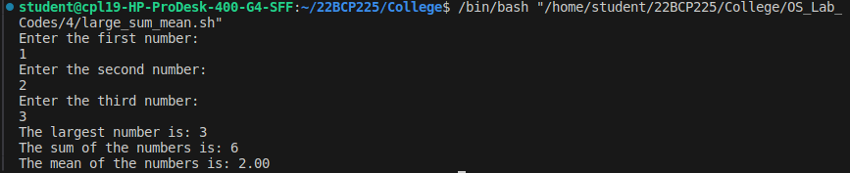

- Write a shell script to check whether the number of command line arguments passed are less than or equal to 5.

Code:
if [ $# -lt 5 ]; then
echo "number of arguments less than 5"
else
echo "number of entered arguments are greater than 5"
fi

Output:

- Write a bash script to print the maximum from command line arguments.

Code:
max=-999999
for i in $@; do
if [ $i -gt $max ]; then
max=$i
fi
done
echo "maximum=$max"

Output:

